1. Create a data module:
You are strongly recommended toAlways place all the data components in a Data Module. This is a special form, invisible at runtime, which just acts as a central repository for data objects, rather then having them scattered across many forms. To create a Data Module, click on File, New, Data Module and then save the module as usual. Click on Project, Add to Project and select the module you have just saved.
2. Create an ADOConnection
Place an ADOConnection component (found on the DBGo tab) on your Data Module. Give it an appropriate name and then click on its ConnectionString property. A dialog box will appear, click on the Build button. You will then see this dialog box:
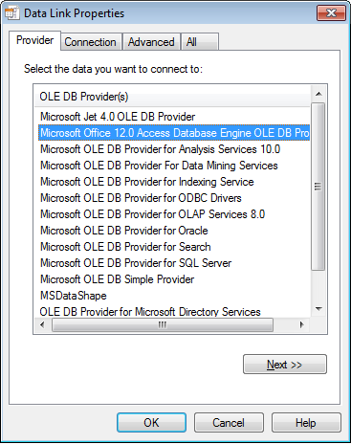
To connect to an Access .accdb database:
- Select "Microsoft Office 12.0 Access Database Engine OLE DB Provider"
- Click on the Next button and in the next dialog box enter the full path of the Access .accdb file you wish to connect to.
(To connect to an Access .mdb database:
- Select "Microsoft Jet 4.0 OLE DB Provider" as shown above. This is not the default.
- Click on the Next button and in the next dialog box enter or browse to locate the Access.mdb file you wish to connect to.)
(To avoid problems when you move your application to another location, you should ask the user to specify the location of the file when the program is run and set up the connection dynamically. Ask if you want help with this.)
Click on a couple of OK buttons and your connection is made.
Finally, set the LoginPrompt property to false to avoid annoying prompts for username and password.
To connect to a MySQL database:

- Select "Microsoft OLE DB provider for ODBC Drivers".
- Click on the Next button and in the next dialog box, click on "Use Connection String" and paste this string in to the Connection String edit box:
DATABASE=zzat;DRIVER={mysql odbc 5.1 driver};OPTION=0;PWD=codd;PORT=0;SERVER=hr-computing;UID=student;
(Replace "zzat" with the name of your database.) This example assumes that you are using the departmental mySQL server. Click on OK a couple of times and if you're lucky it will work. This can be a bit temperamental so ask if you need help.
3. Add a DataSet to your Data Module
Place an ADODataSet component on your Data Module. Give it a suitable name. Set its Connection property to the ADOConnection you just made. Double-click on its CommandText property and this window will open, showing the tables and fields in the database. Select the fields to create the SQL statement to return the data you need. For example, "select * from Car" will extract the entire contents of the Car table.
(If you want an entire table you can use an ADOTable component but this is less flexible. The TADOQuery component is similar to the ADODataSet but a bit less user-friendly.) See Use Queries to Select Records for more details.
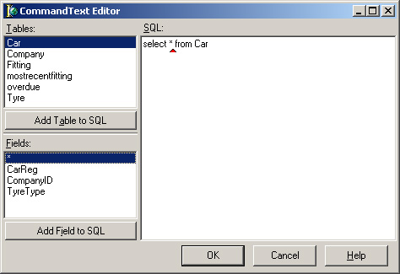
4. Add a DataSource component to your data module
Place a DataSource component on your Data Module. This is a general-purpose data access component, found on the Data Access tab. Name it and set its DataSet property to your table component.
5. Repeat steps 3 and 4 for each table to wish to use in your project.
Your Data module is now ready to use. You will need to add it to the uses list of any form you wish to use it in.

